Final

Using Audit Trail Information in Workday to Troubleshoot Issues

Created by Kristina Kelpe, 12.17.25 - Requested by Laurel

Purpose

Workday’s audit trail is one of the most powerful and misunderstood troubleshooting tools. When used correctly, it helps answer:

- Who made this change
- When it happened
- What data changed and the prior value
- Whether the change came from a user, data conversion, or system process

This job aid focuses on how to think about audits, not just where to click.

Key takeaway: Effective troubleshooting starts by identifying the correct business object and reviewing its audit trail as close to the data as possible.

Core Principle: Start with the Business Object
Workday is a business-object–modeled system. Audit data is tied to business objects, not screens or reports.
Rule of thumb:
Get as close as possible to the data you are troubleshooting, then open the audit trail from there.
Before opening an audit, ask:
- What data am I trying to understand?
- Which business object owns that data?
- How can I navigate directly to that object?
Starting too high level often results in:
- Missing the relevant audit
- Seeing unrelated data
- Misinterpreting what object the audit reflects
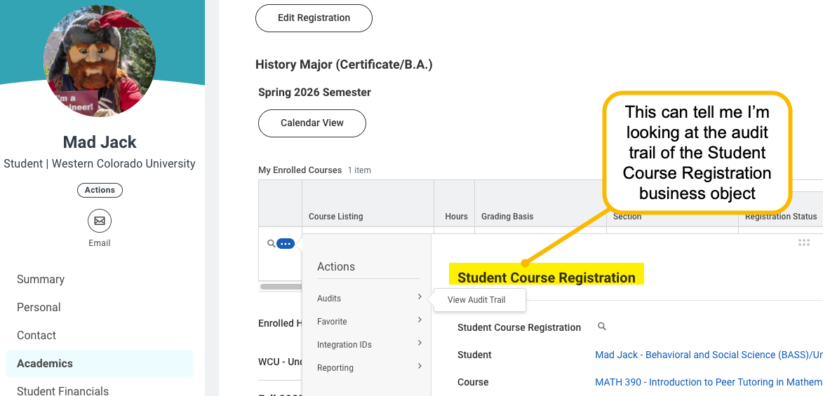

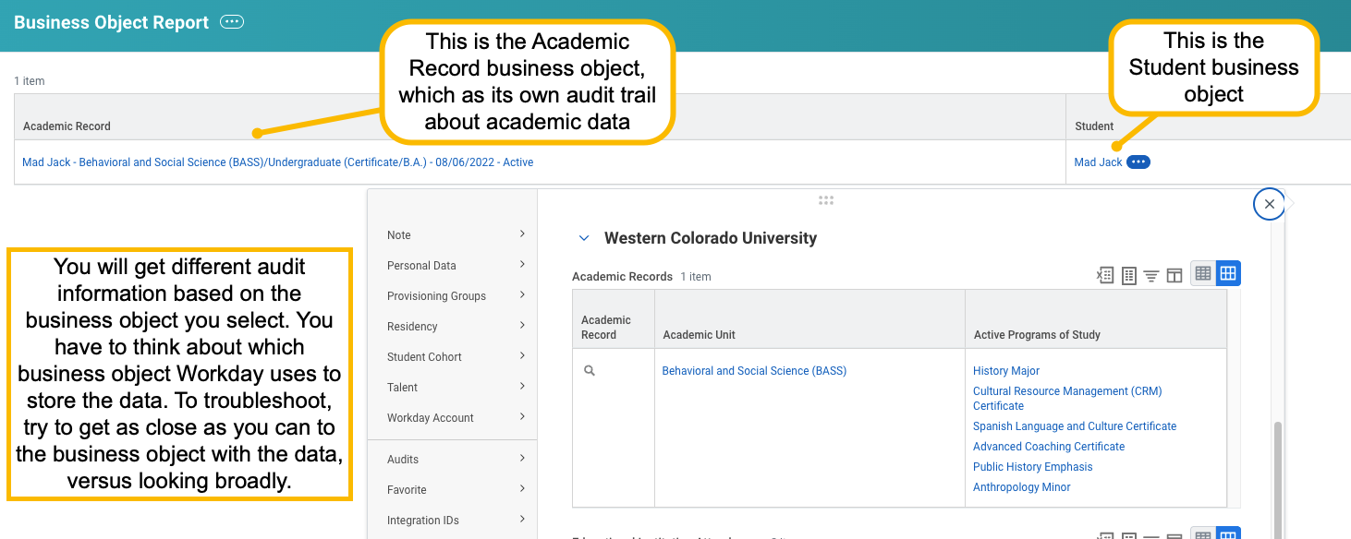

Recommended Troubleshooting Approach

Step 1: Navigate to the Specific Record
Always start from the most specific object available.
Common examples:
- Student course registration → Student Course Registration
- Program of study assignment → Academic Record / Program of Study assignment
- Course section details → Course Section Definition
- Academic structure issues → Academic Unit
Avoid summaries or list views when possible.

Example: Who Registered a Student in a Course?
- Navigate to the Student Course Registration record, not the course listing.
- Select Related Actions → Audits → View Audit Trail.
- Adjust the date range to include all relevant activity.
- Review the By User column.
- Use the Reference ID to confirm the registration event, even if the label is unclear.
Key insight:
Audit rows may not say “Registered Student.” The combination of business object, reference ID, and user is usually enough to determine what happened.

Step 2: Open the Audit Trail
From the record:
- Related Actions
- Audits
- View Audit Trail
- Open in a new window
Adjust the date range as needed. Backdating to the start of implementation or conversion is often helpful.

Step 3: Review Key Fields
Focus on:
- By User
- Date and Time
- Attribute
- Prior Value and New Value
- Reference ID
Some audits are explicit. Others require interpretation using timing and context.

When the Targeted Audit Is Not Helpful

Use the Global Audit Trail Carefully
Related Actions → Audits → View Audit Trail (top level)
This returns a large, unfiltered data set and should be a last resort.
Tips:
- Switch to show all results
- Use browser search (Ctrl or Cmd + F)
- Search for keywords such as program or registration
Limitations:
- Cannot reliably filter by business object
- Requires context and patience

Understanding Additional Data Audits
Additional Data audits often:
- Reference the Student business object
- Do not clearly show academic-record-level changes
If results are incomplete:
- Confirm whether the audit is tied to Student or Academic Record
- Navigate to Find Academic Records
- Open the audit trail from the academic record instead
This is especially important for Registrar and Student Records troubleshooting.

Practical Troubleshooting Mindset
Audit trails are not always intuitive or consistently labeled. Effective troubleshooting requires:
- Understanding Workday’s data model
- Thinking in business objects
- Using context, reference IDs, and timing
- Accepting some trial and error
Even when audits are imperfect, they usually provide enough information to identify who made a change, when it occurred, and who to contact next.

Audit Gotchas in Workday

1. Audits Follow the Data, Not the Screen
Audits are tied to the business object that owns the data. Screens may display multiple objects.
Legato guidance: Pause and confirm which data is being changed before reviewing the audit.

2. Audit Labels Do Not Match Institutional Language
Labels like “Assignment Added” or “Status Change” rarely align with how institutions describe work.
Legato guidance: Expect translation. Use reference IDs, timing, and user context.

3. Not All Audits Show Value Changes
Some audits show prior and new values. Others only show that something changed.
Legato guidance: Look for related changes around the same time.

4. Conversion and Cleanup Can Look Like User Activity
Audits do not clearly distinguish conversion from operational changes.
Legato guidance: Use dates, patterns, and system users to interpret activity.

5. Audits Support Investigation, Not Perfection
Audits rarely tell a complete story on their own.
Legato guidance: Aim for enough clarity to understand cause and next steps.

Key Takeaways
- Always think in business objects
- Expect to translate Workday language
- Not all changes surface cleanly
- Context matters as much as the data
- Audit trails are a critical operational and governance tool when used correctly

Unedited Images
